Computer Language Coding Concepts

Command Arguments in a Diagram
The principle of command arguments is explained in the article Command Arguments. This article demonstrates their expression in diagrams.

Parameters of a command are expresed as circles inside a square.

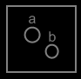

The square represent the command. The circles represent the parameters.

When a command is called, objects are filled into the parameters for the command. The objects filled in are arguments for the command. In the diagram this means the object symbols inside the call will become pointers to objects.



The diamond represents the call. The circles represent the parameters, and the lines represent pointers to the objects. (The objects themselves are not shown in the diagram above.)

There is a difference between a parameter and an argument. A parameter is part of a command definition and does not refer to any particular object yet. The parameters are also present in a call to the command, but the objects filled into the parameters are called the arguments.

When a call is considered a call upon objects, rather than a call with objects filled in as the arguments, the notation would change to:

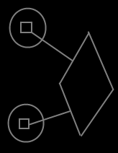

The diamond is the call, the circles are the objects called upon, the squares both represent the definition of the command, so the definition of the command is displayed twice: once for each object.

When you display both notations in the same diagram, it would look like this:

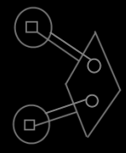

But it looks like such overkill to display both sides of the relationship between commands and objects. It also does not express that the two lines of a pair are actually linked to eachother.

Instead, the two lines of a pair are merged into a hybrid display:

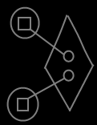

It emphasizes the interchangability between object commands and command arguments. It also makes the objects available inside the command call, as opposed to the notation of just a call upon objects.

This is an implicit display, because a connection between two symbols usually means, that they are the same thing, but in this implicit notation an object is tied to a command. An object and a command are never the same thing. However, this notation is a clear depiction of the interchangability between command parameters and the commands of an object.

I call it an implicit display, but on the other hand it
does explicitly display a connection between the squares inside the circles and the circles inside the diamond. The diamond and the larger circles are implicitly connected through their children.

See also: Command Objects, Command Parameters in a Diagram, Commands in a Diagram

Author & Copyright: Jan-Joost van Zon Date: May 24, 2008 – May 29, 2008 Location: Oosterhout, The Netherlands Status: Finished

